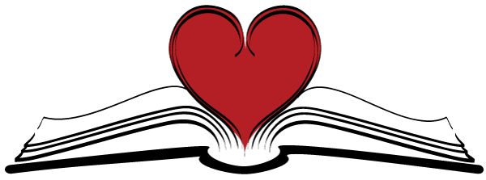

Lovers of Literacy!
Join Us at Medford Arts Center
To Share your Passion for Poetry
And Appreciation of the Written and Spoken Word
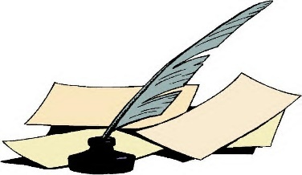
DATE: Friday, June 22, 2018
TIME: 7:15 PM – 9:30 PM
LOCATION: Medford Arts Center
18 North Main Street, Medford, NJ
THIS MONTH WE CELEBRATE DADS, COMMENCEMENTS, BEGINNINGS AND ENDINGS…
AND “OH, THE PLACES YOU’LL GO!”
Refreshments will be served.
This event is free and open to the public.
WE LOOK FORWARD TO SEEING YOU AT
MEDFORD ARTS CENTER!

