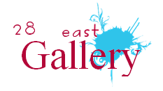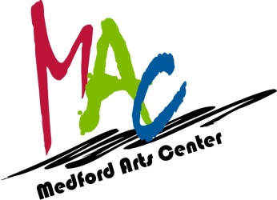

2018 Historic MedfordPlein Air

Call to artists! Celebrate open-air painting in the Historic Town of Medford and Medford Lakes, New Jersey. Medford, founded in 1847, holds a treasure chest of historical sites that evoke the charm of the past. The beautiful lakes, pinelands, and Rancocas Creekoffer the outdoor painter numerous inspirational subjects.

This juried Plein Air event is sponsored by 28 East Gallery LLC, and will run from Friday, May 25 through Saturday, June 23, 2018 During this period the Medford Arts Center will also host a Watercolor Memories show and will be a part of the 2nd Friday Art Walk. On June 10^{th,} the Medford Business Association will host its Annual Art, Wine, and Music Festival which attracts over 10,000 attendees.

A maximum number of 30 artists will be accepted for the Historic MedfordPlein Air on a first-come, first-served basis with a $15 registration fee. Register by contacting the gallery at our email, mpeasenj1@verizon.net, or by calling Melanie at 856-701-2578. Artists must have Canvas(s) stamped on Friday May 12that the Medford Arts Center, 18 North Main Street, Medford, NJ 08055 during normal business hours, 1 – 5PM, or make other arrangements with Melanie. Only 2 entries per artist will be accepted due to space considerations.

Artists are invited to paint scenes within Medford Township and the borough of Medford Lakesbetween May 12 and May 23. Framed works must be delivered on May 23/24 to the Medford Arts Center between the hours of 1 – 5pm. Judging will take place the morning of Friday. May 25. Cash and Special awardsare to be provided by local merchants. Art will be exhibited starting at a reception on May 25, 6:00 – 9:00 p.m. at Medford Arts Center with an awards ceremony at 7pm.

Artists may sell their paintingsto the publicwith 30% of the sale designated as Medford Arts Center commission and 10 % 28 East Gallery commission to be utilized to promote the works and continue to exhibit through June 23.The Medford Arts Center handles all purchase payments, and provide payment to artist at the conclusion of the show.
2018 Historic MedfordPlein Air Schedule:
May 11, 1-5pm Registration deadline, Submit Registration and have Canvas stamped by 28 East Gallery LLC at the Medford Arts Center, 18 N. Main St., Medford.

May 12 -May 23 - Artists may visit, plan, sketch and paint artwork withinMedford, Medford Township and the Borough of Medford Lakes

May 23 and 24 1pm- 5 pm Artists submit paintings with label for display

May 25
- Friday am Judging
6pm-9pm Paintings on Display to Public
- 7pm Award Presentation

June 24
- Sunday 1-5pm Artists pick up unsold works

Guidelines:
- The artwork should showcase the historic buildings, streetscapes and/or landscapes of Medford, Medford Township and the Borough of Medford Lakes, NJ.
- Artists must submit a registration and have their canvas or paper stamped on the designated date.
- Artwork must be two-dimensional.
- The maximum entry size is 24 inches by 24 inches, not including matting.
- There is a $15 entry fee for this event.
- Artwork submitted for Plein Air judging and sale must be framed.
- Artists must provide their own supplies and equipment, including art supplies,and ready-made frame or mat.

Liability
28 East Gallery will make every effort to protect all submitted artwork from damage or loss. The Gallery reserves the right to publish for publicity reproductions of the entries. Artists are expected to self insured for the art works.

Contact for more information:
Melanie Pease, 28 East Gallery LLC, mpeasenj1@verizon.net, 856-701-2578

